# Application Architecture

## Simple Search Engine Application using Django Rest Framework

The below scenario can server up to 400000 hits per hour with Red hat server OS, 32 GB RAM and it can be optimized based on the number of core processor we are using.

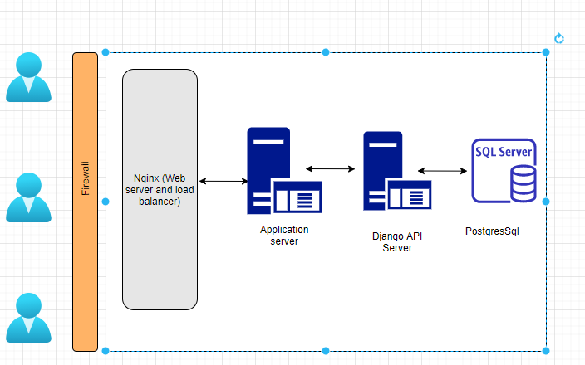

Request with Caching Mechanism This can improve the performance by 50% minimum as most of the request are served from the cached server. We can set the caching time limit and we can overwrite the record in cache directly whenever save happens in the record.

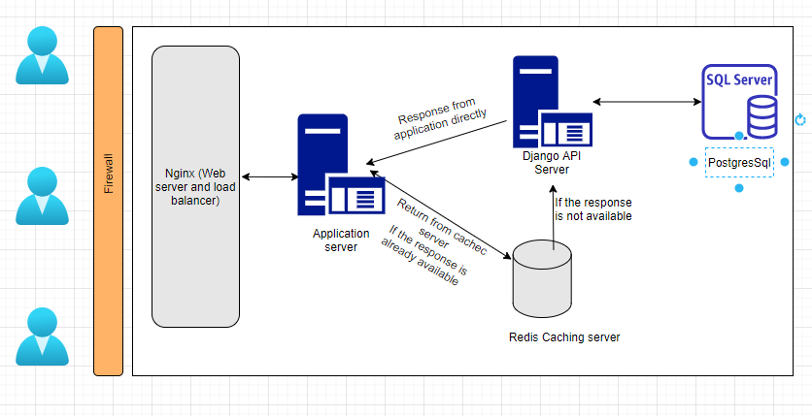

Third step of improvement is through horizontal partitioning the POST and COMMENTS table. This way we can reduce the load in indexing. This is useful when the search happens with large dataset.

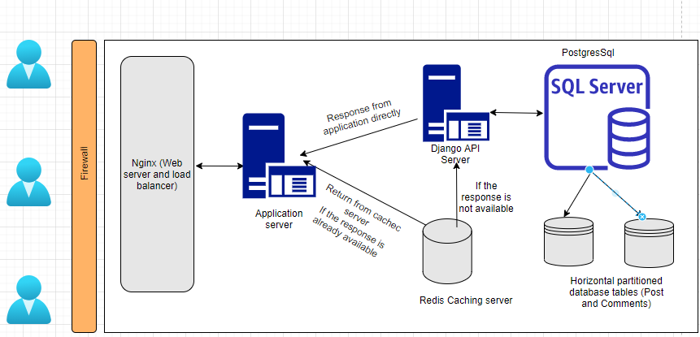

# Application Setup

* To Activate virtual environment
* Create the virtual environment using the command **python –m venv invensisvenv**
* Then type ./invensisvenv/Scripts/activate

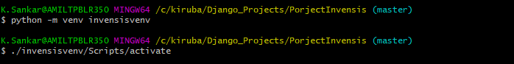

* Installed the required packages using the command
* Pip install –r requirements.txt

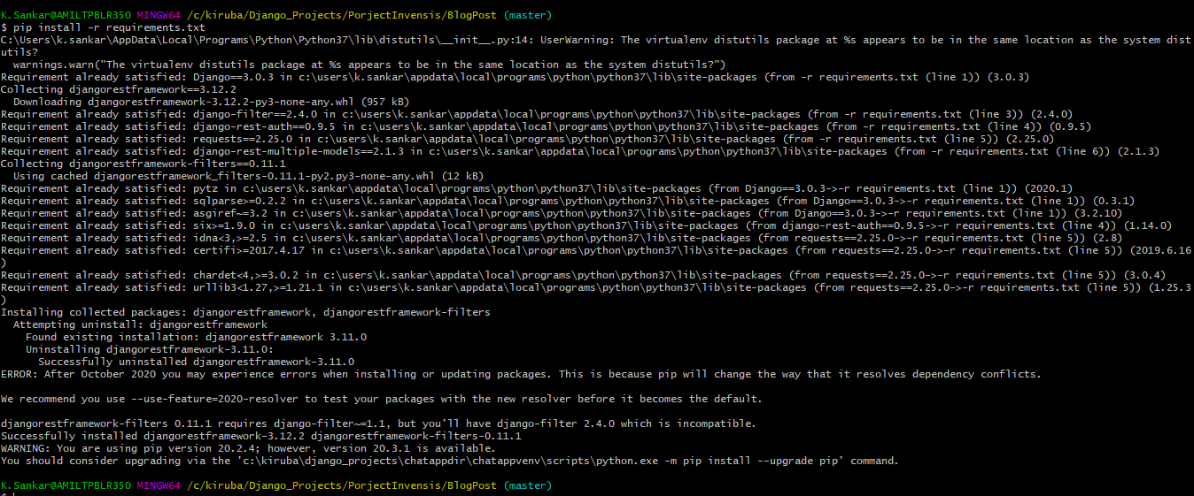

* Do the database setup for development server using the below command

python manage.py migrate

python manage.py createsuperuser

Now type the username and password when prompted

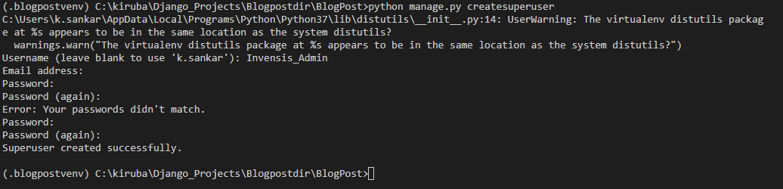

* Start the development server using the below command

python manage.py runserver

* Check whether the development server is running using the url

<http://127.0.0.1:8000/>

* Log in to the portal as admin

<http://127.0.0.1:8000/admin>

username: as provided above

password : as provided above

Rest of all the users can be created using the API links.

**As session authentication is enabled all the API’s can be accessed via browser itself.**

These API’s can only be used by Administrator

|  |  |  |  |
| --- | --- | --- | --- |
| **Model** | **Description** | **HTTP Method** | **API syntax** |
| User | List all user | GET/ POST | http://127.0.0.1:8000/users/ |
|  | Get and update specific user | PUT/ DELETE | [http://127.0.0.1:8000/users/<userid>](http://127.0.0.1:8000/users/%3cuserid) |
|  | Get specific user by email ID | GET | [http://127.0.0.1:8000/users/?email=<emailID>](http://127.0.0.1:8000/users/?email=%3cemailID) |
|  | Get specific user by first name | GET | [http://127.0.0.1:8000/users/?first_name=<first_name>](http://127.0.0.1:8000/users/?first_name=%3cfirst_name) |
|  | Get specific user by last name | GET | [http://127.0.0.1:8000/users/?last_name=<last_name>](http://127.0.0.1:8000/users/?last_name=%3clast_name) |
|  | Get all users records containing the seachvalue in fullname,username, email | GET | [http://127.0.0.1:8000/users/?search=<searchvalue>](http://127.0.0.1:8000/users/?search=%3csearchvalue) |

List of other API’s that can be used by all users.

|  |  |  |  |
| --- | --- | --- | --- |
| **Model** | **Description** | **HTTP Method** | **API syntax** |
| Post | List all Post | GET/ POST | http://127.0.0.1:8000/posts/ |
|  | Get and update specific post | PUT/ DELETE | http://127.0.0.1:8000/posts/<postid> |
|  | Get specific user by title | GET | http://127.0.0.1:8000/posts/title=<title> |
|  | Get specific user by content | GET | http://127.0.0.1:8000/posts/content=<content> |
|  | Get specific user by subtitle | GET | http://127.0.0.1:8000/posts/subtitle=<subtitle> |
|  | Get all users records containing the seachvalue in title, subtitle, content | GET | http://127.0.0.1:8000/posts/?search=<searchvalue> |
|  |  |  |  |
| Comments | List all Comments for the Post | GET/ POST | http://127.0.0.1:8000/posts/<post:id>/comments/ |
|  | Get and update specific comment for a specific post | PUT/DELETE | http://127.0.0.1:8000/posts/<postid>/comments/<commnetid> |
|  | Get all comments for the post with the search critiria | GET | http://127.0.0.1:8000/posts/<postid>/comments/?search=<searchvalue |
|  |  |  |  |
| Search All | Search all the models with the specific search value where the current user has access | GET | http://127.0.0.1:8000/users-posts/?search=<searchvalue> |

# Navigation for testing the API’s

Once the development server is started you can login to the application using the URL below.

Login to the application using

http://127.0.0.1:8000/api-auth/login/?next=/users/

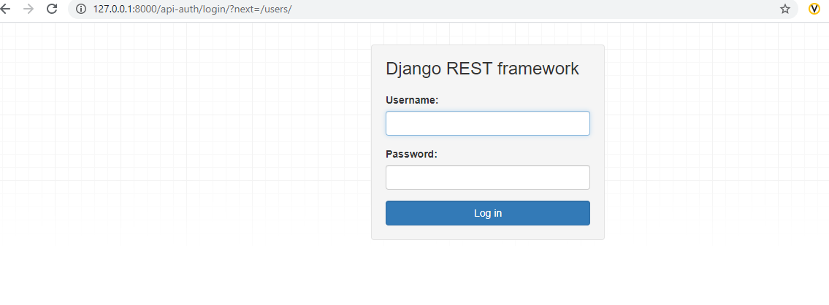

Sample screen shot of user request

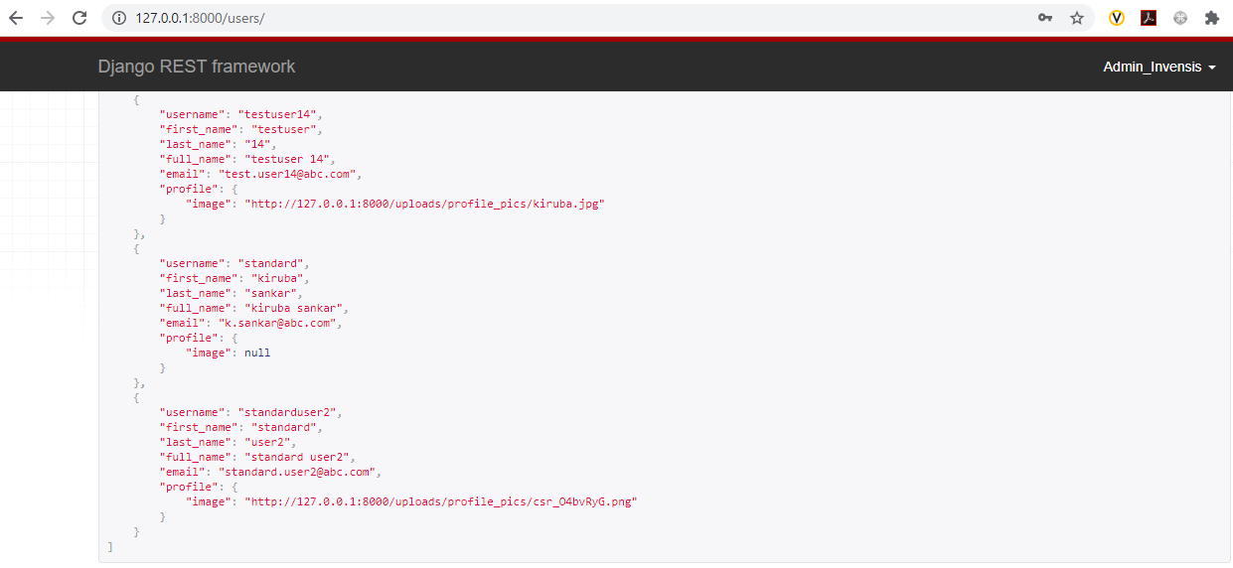

Every GET request will display the option to POST a new document depending on the access. The POST request has both the Raw data format and HTML format.

Below is the screen shot for a user creation.

